**Section 4**

***Joining data***

Adding sheets

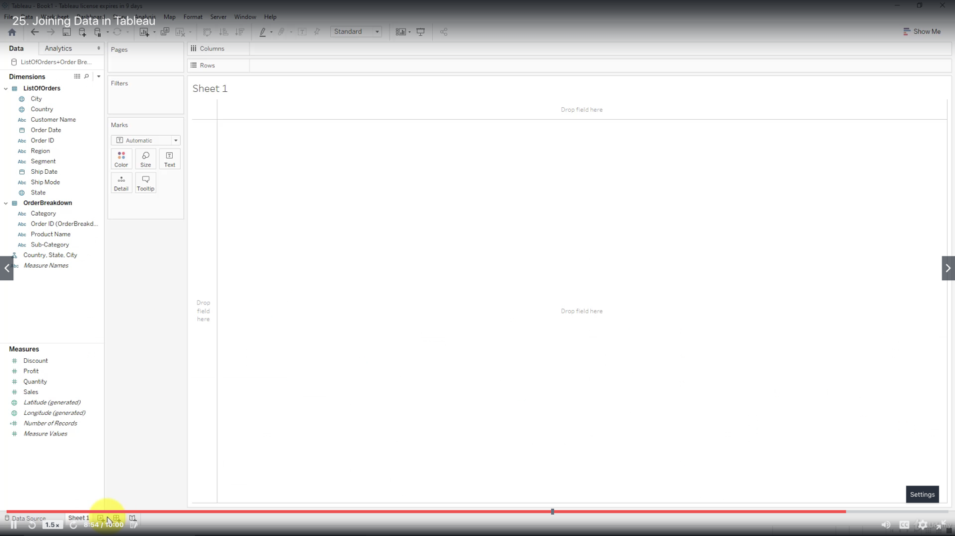

Add 1st sheet

Double click 1st sheet

Drag 2nd sheet

Edit how to join

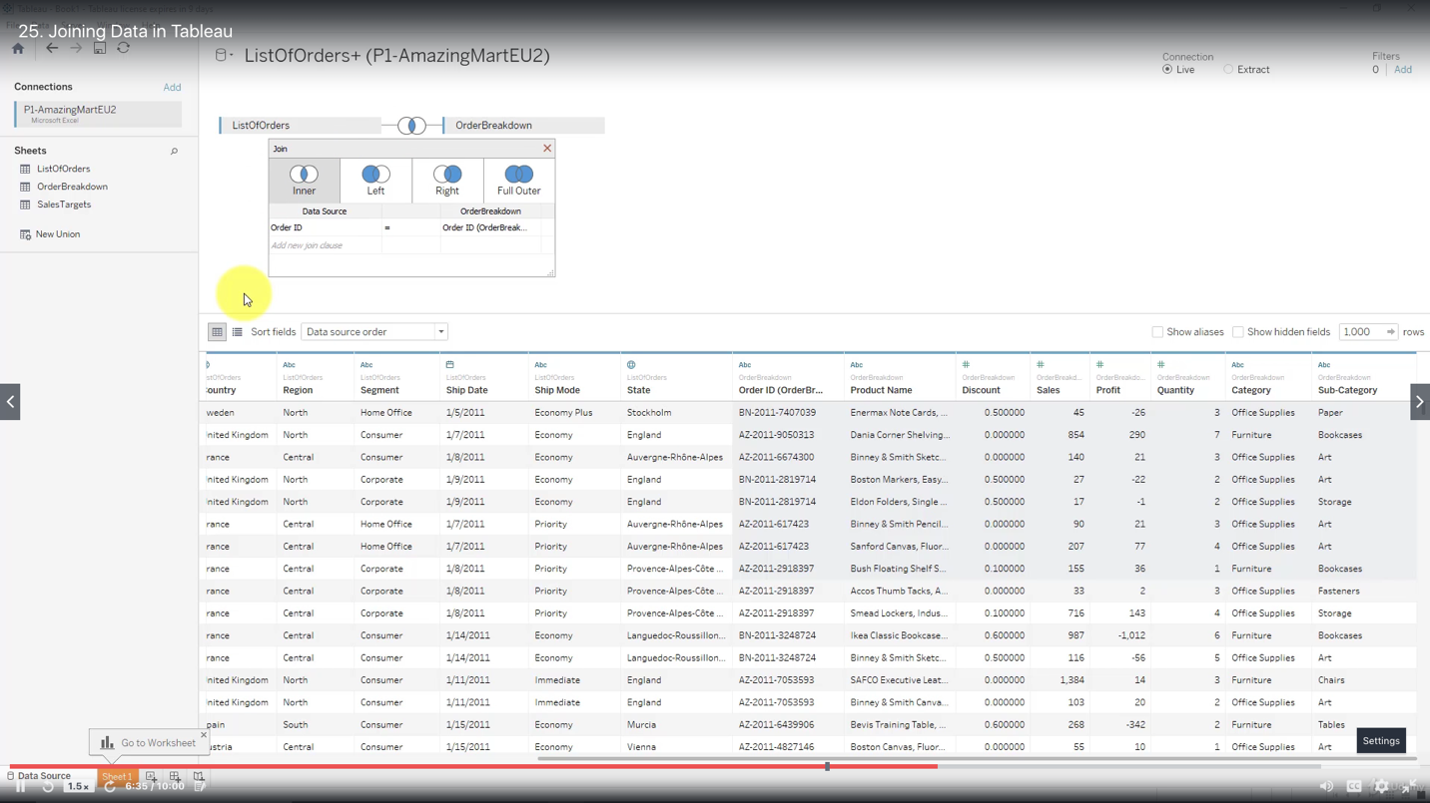

Rename

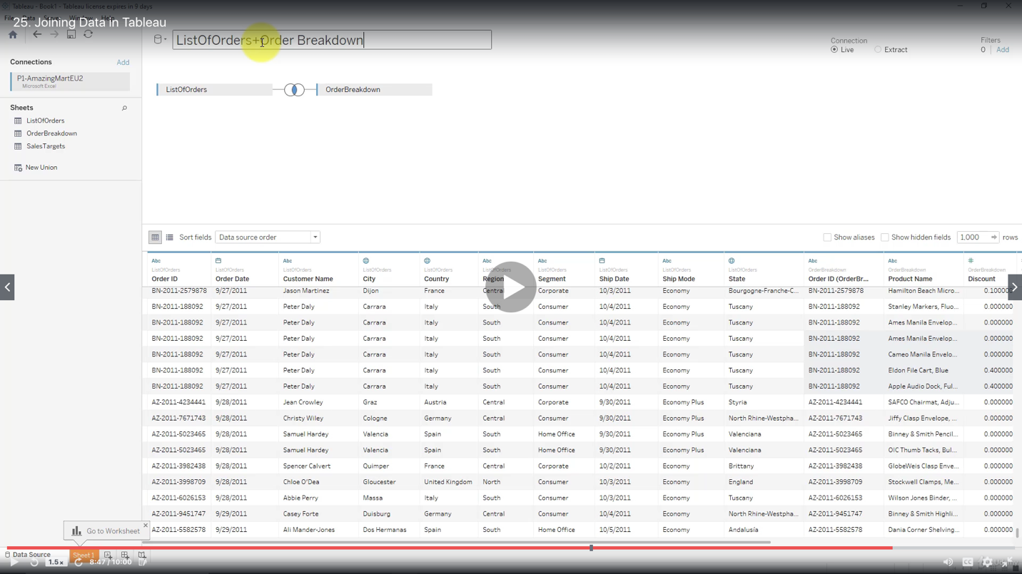

***Creating a Map, working with Hierarchies***

When there are hierarchies present in the Dimensions and Tableau needs to know about them for you to build your visualization - you need to create Hierarchies.

You may remove automatic hierarchies and create your own.

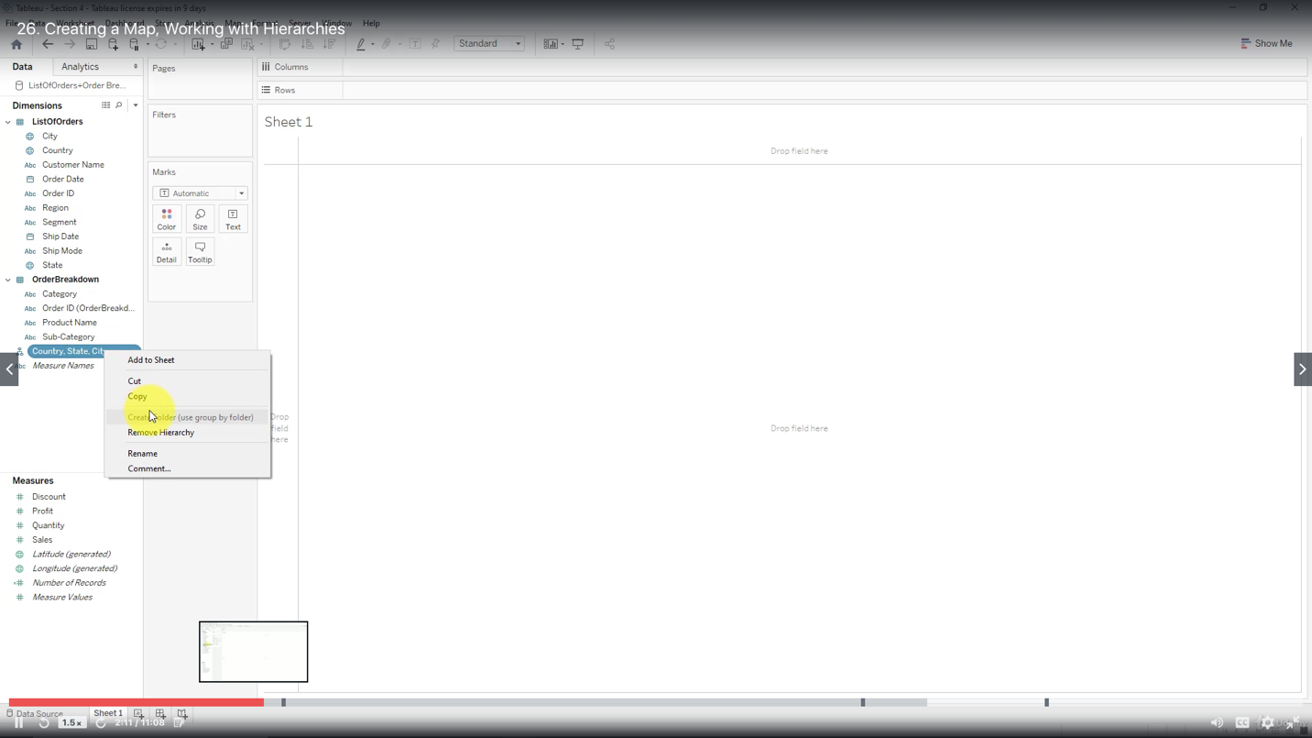

Drag City onto Country to create Hierarchy, drag State in between

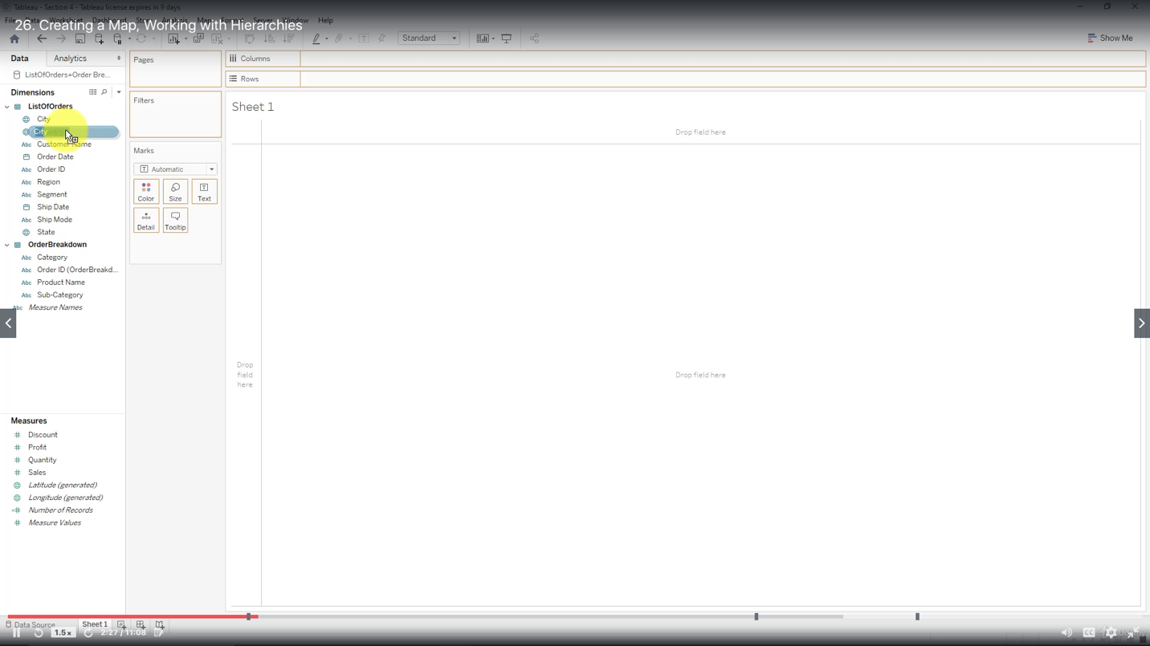

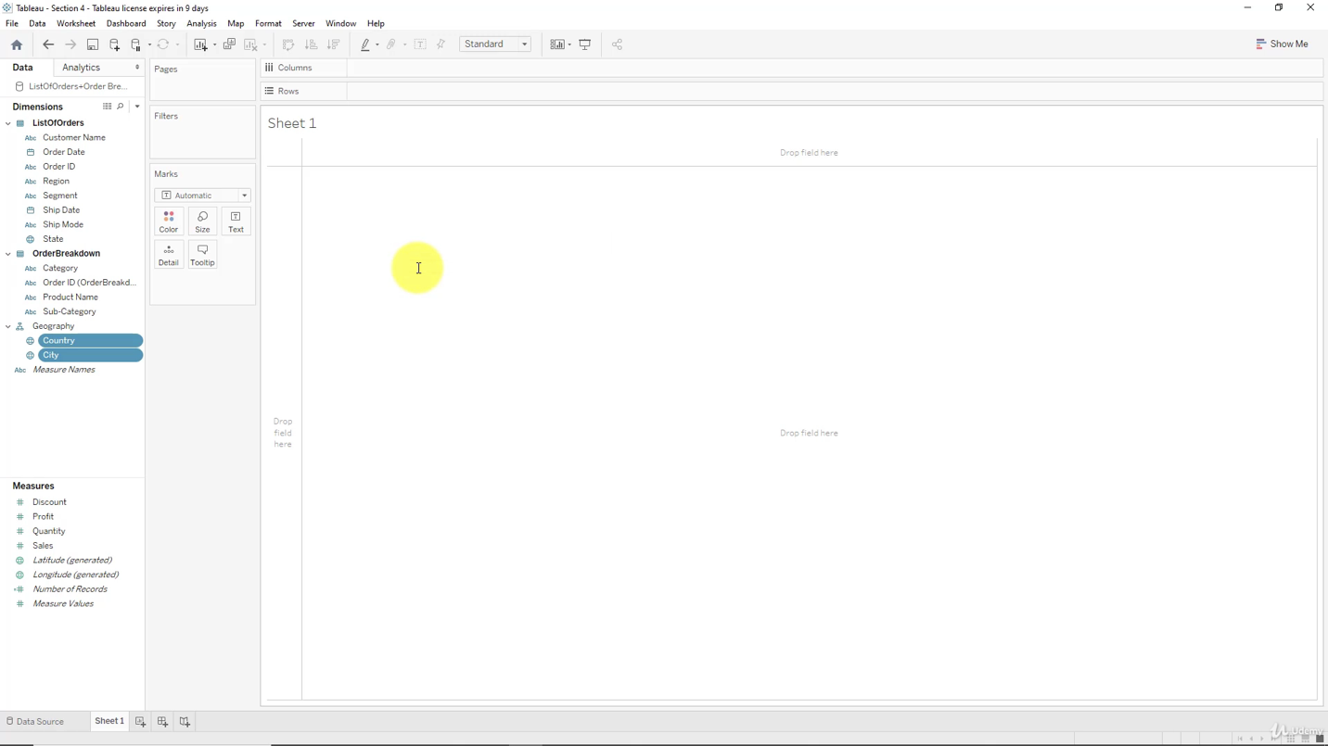

Drag country into working area

View by hierarchies

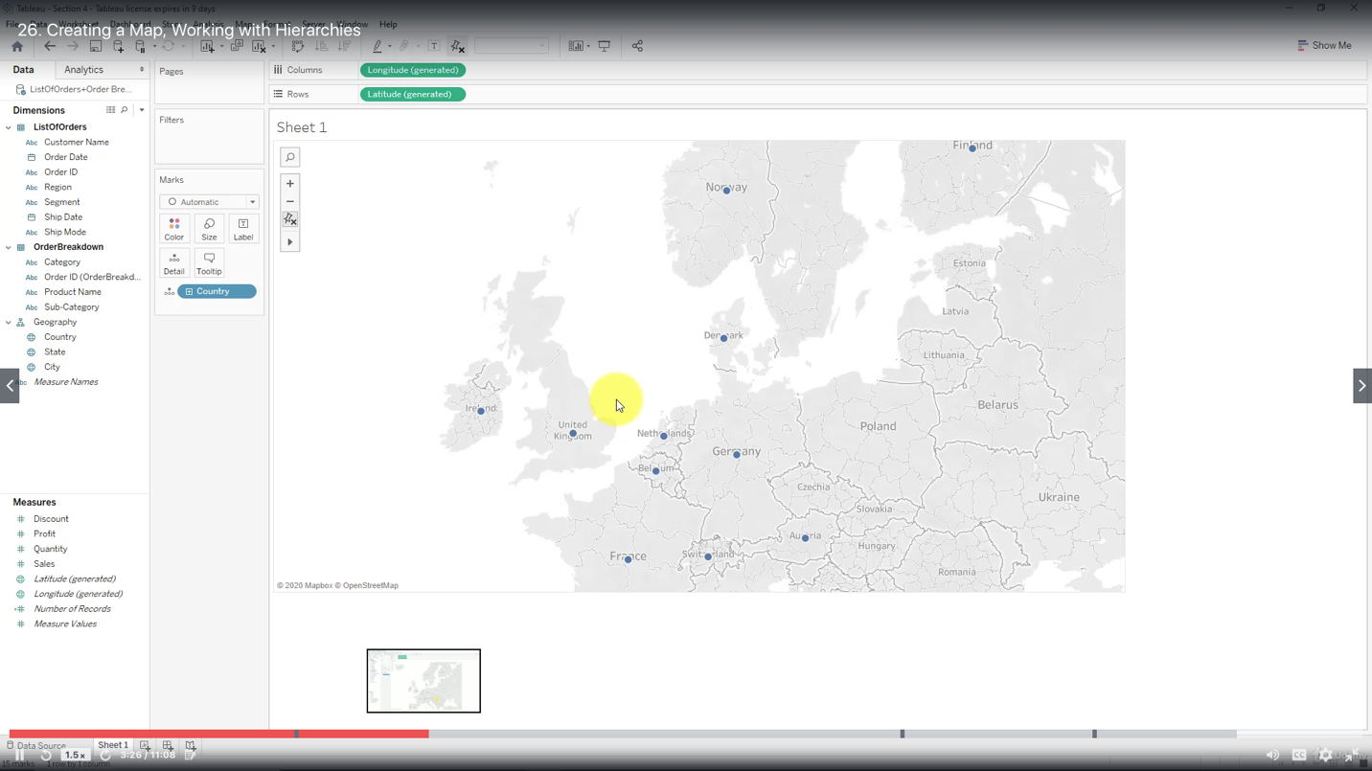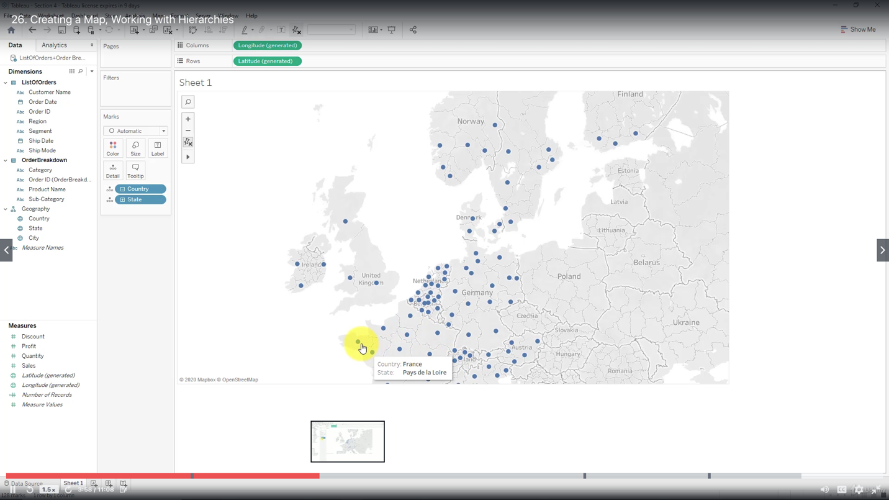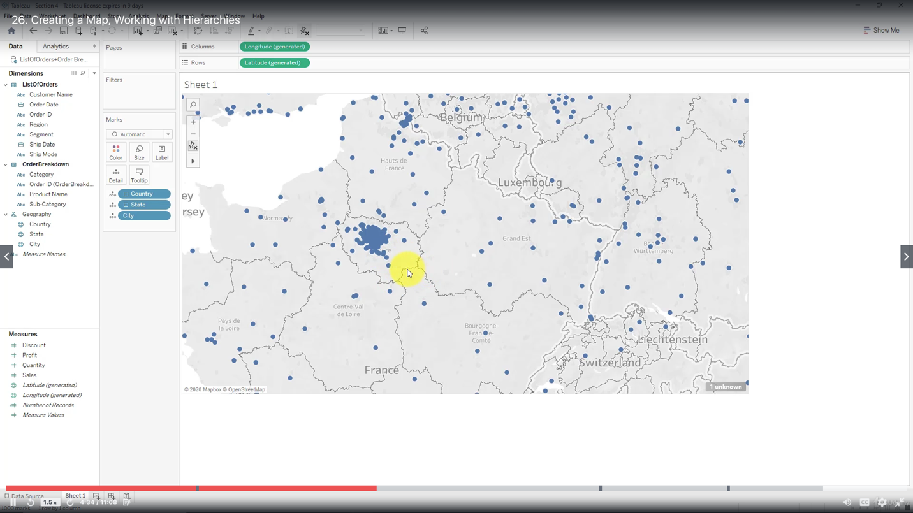

Add a filter

Drag Order Date into Filter, select Year, right click to show filter

Drop down menu - single value slider

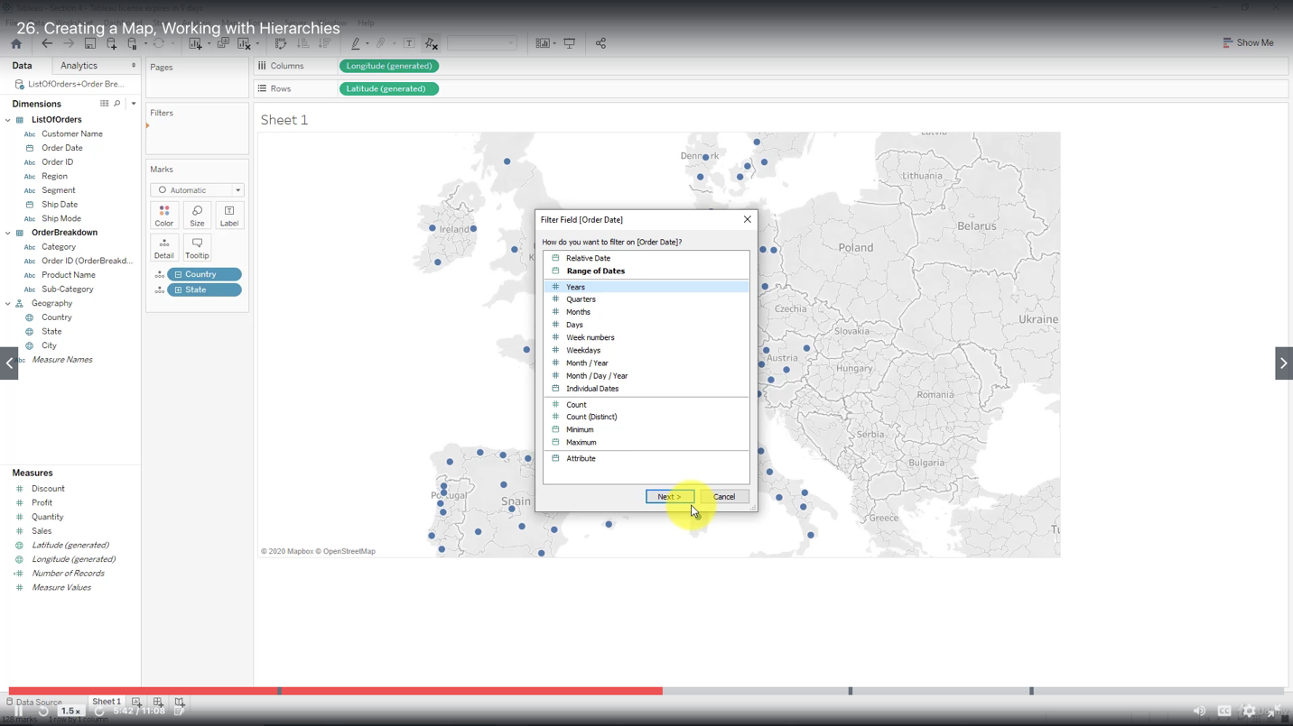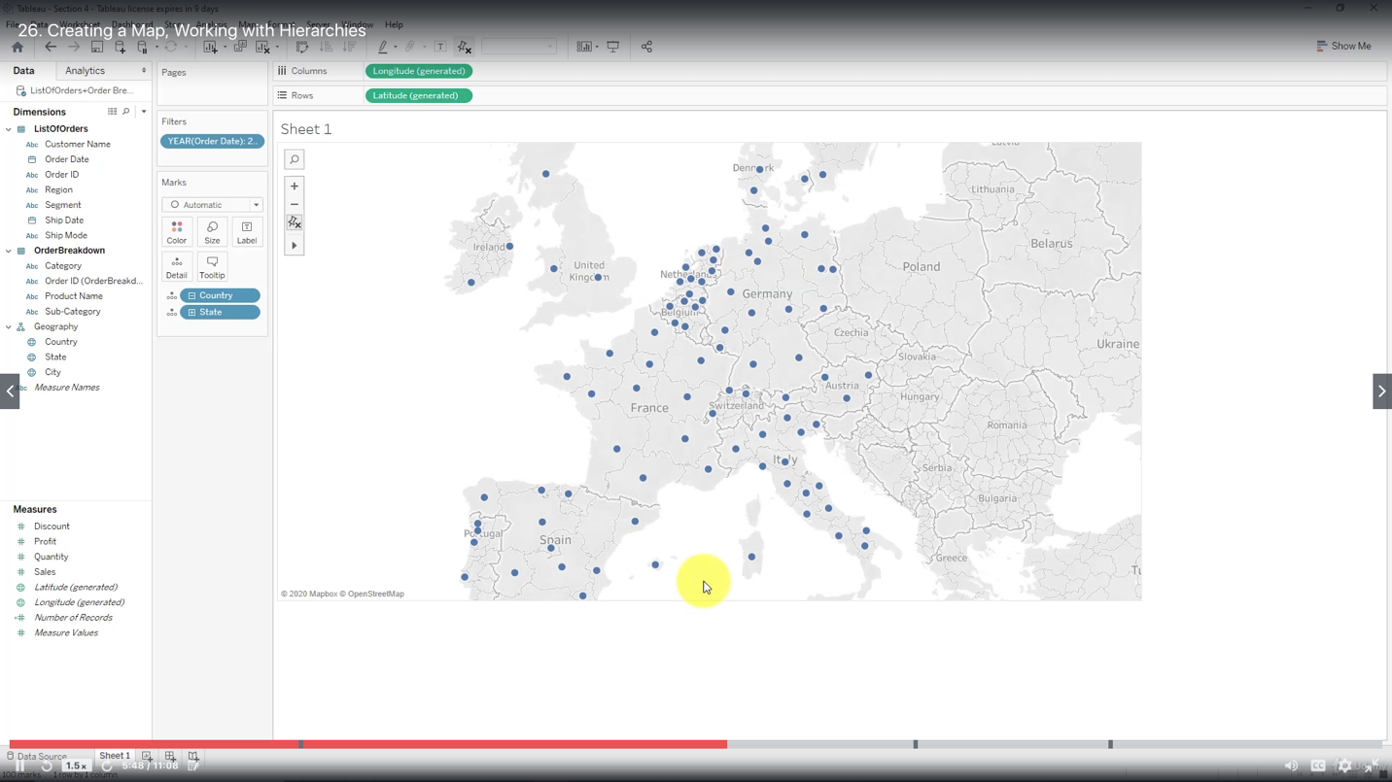

Create a calculated field (right click)

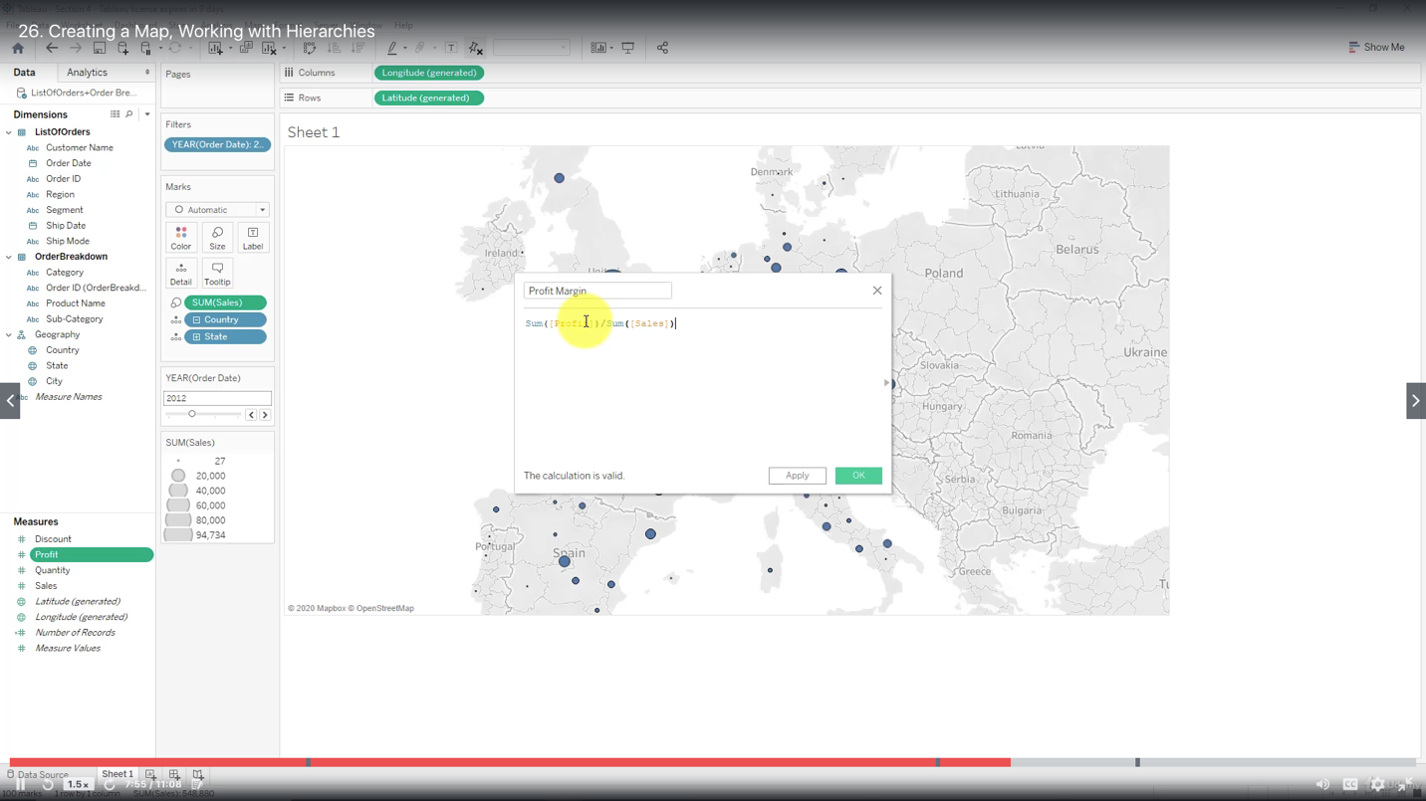

Edit colors (edit colors, choose palette, advanced - start / end)

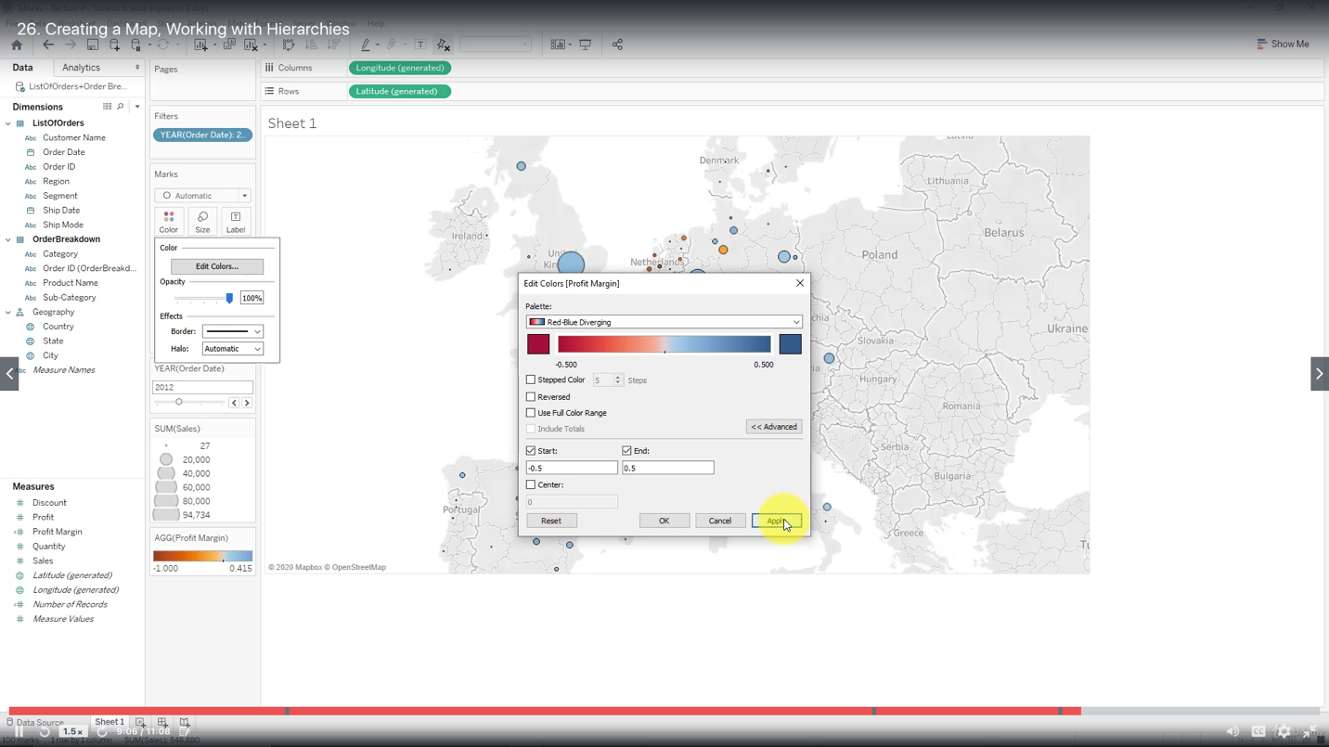

***Creating a Scatter Plot, Applying Filters to Multiple Worksheets***

Ways to apply a filter

All using this data source

Selected worksheets

Only this worksheet

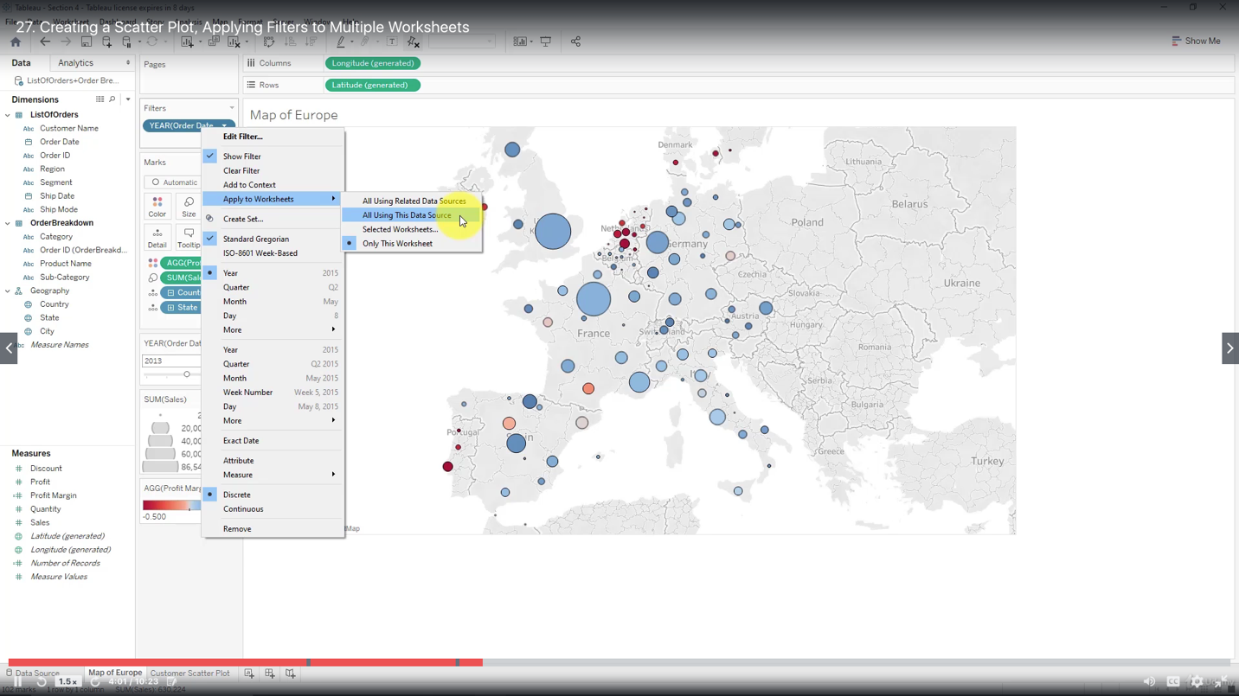

Sum - Sales to Column,

Sum - Profit to Row,

Customer Name to Detail

AGG - Profit Margin to Color

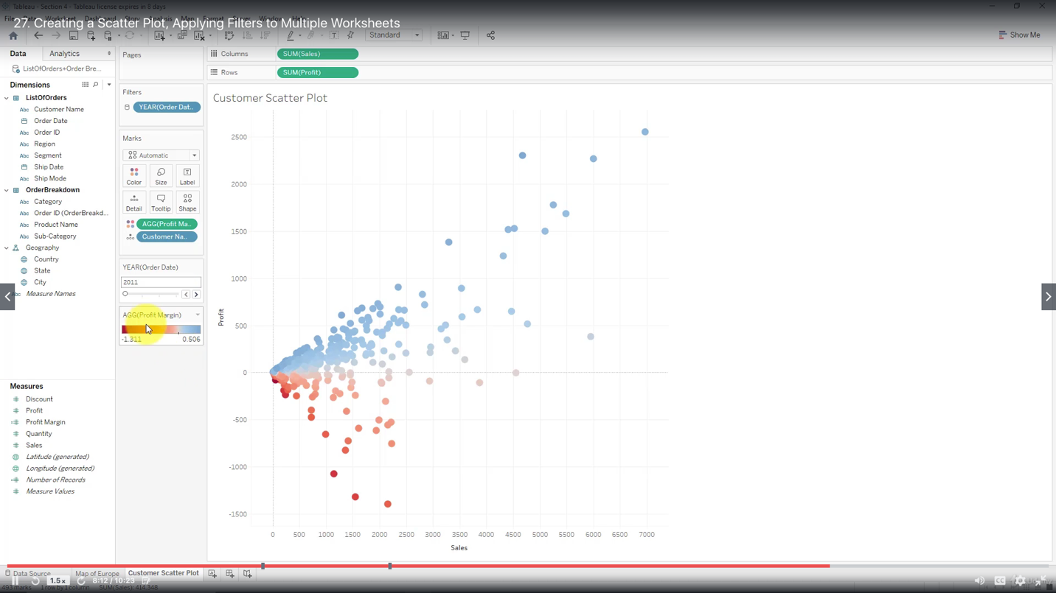

***Creating a Dashboard***

Simply drag the worksheets onto the dashboard to add them.

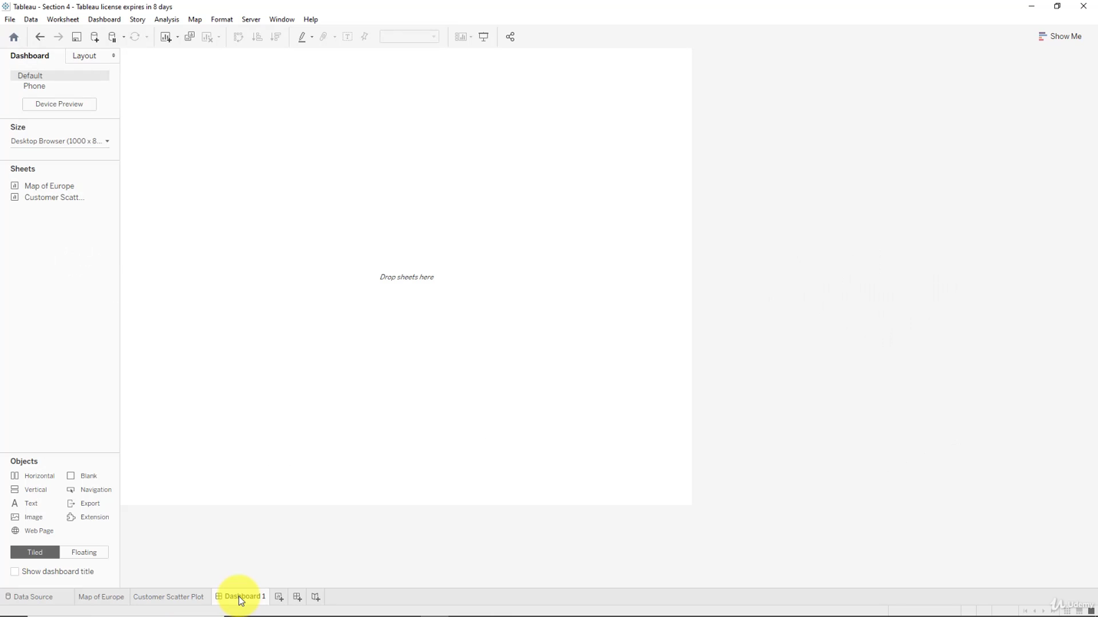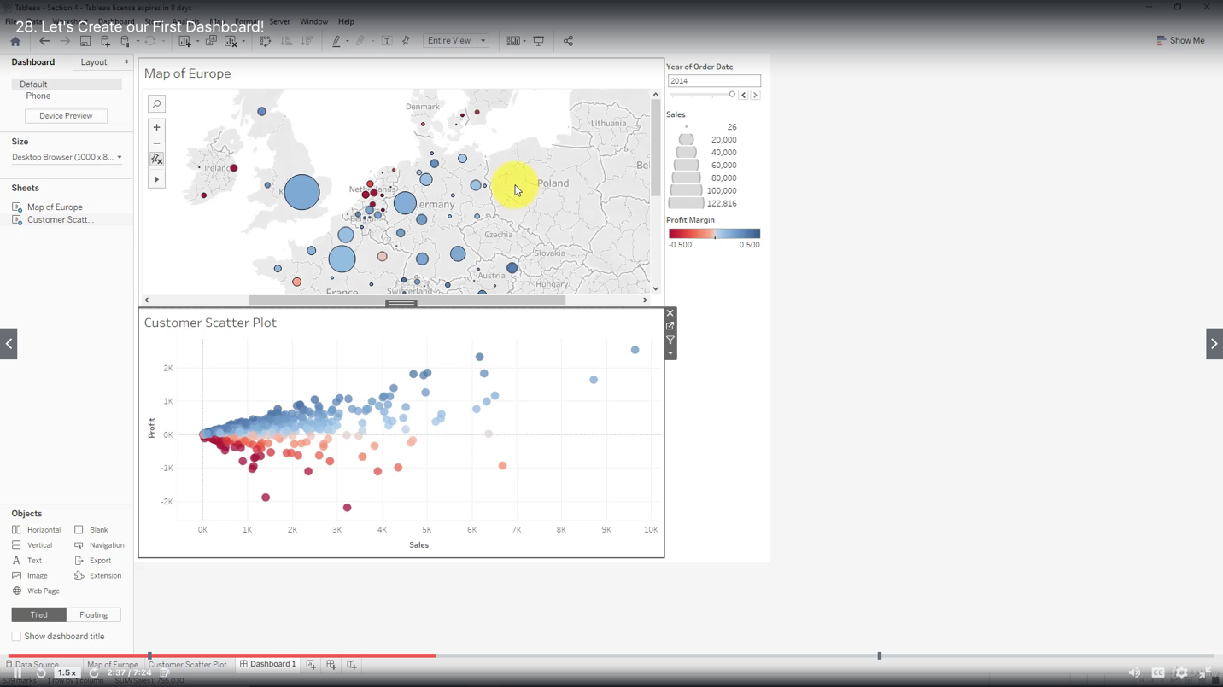

***Adding an Interactive Action - Filter***

You can automatically generate Action: Filter through dropdown of the selected worksheet in your dashboard

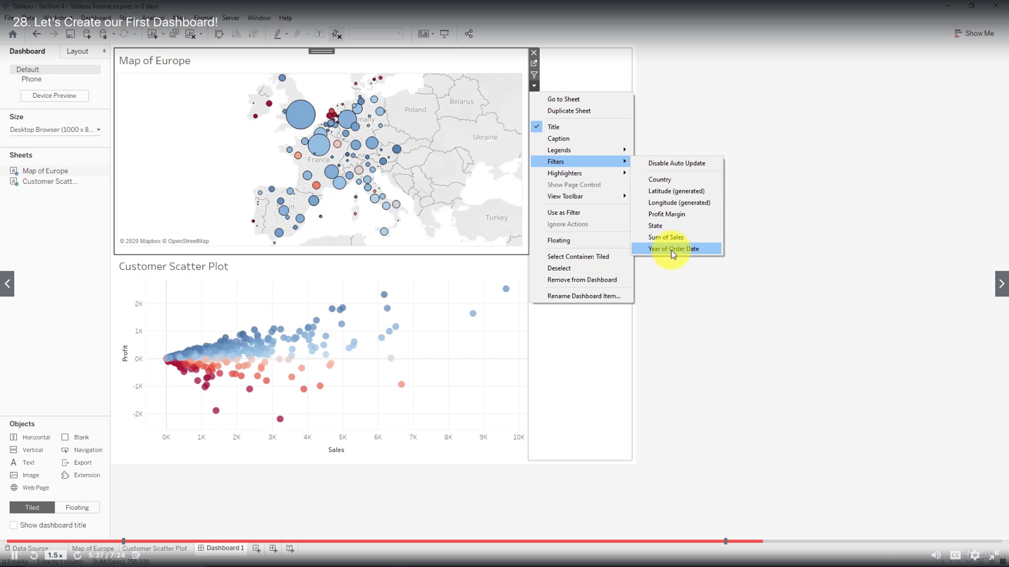

Another way to add actions

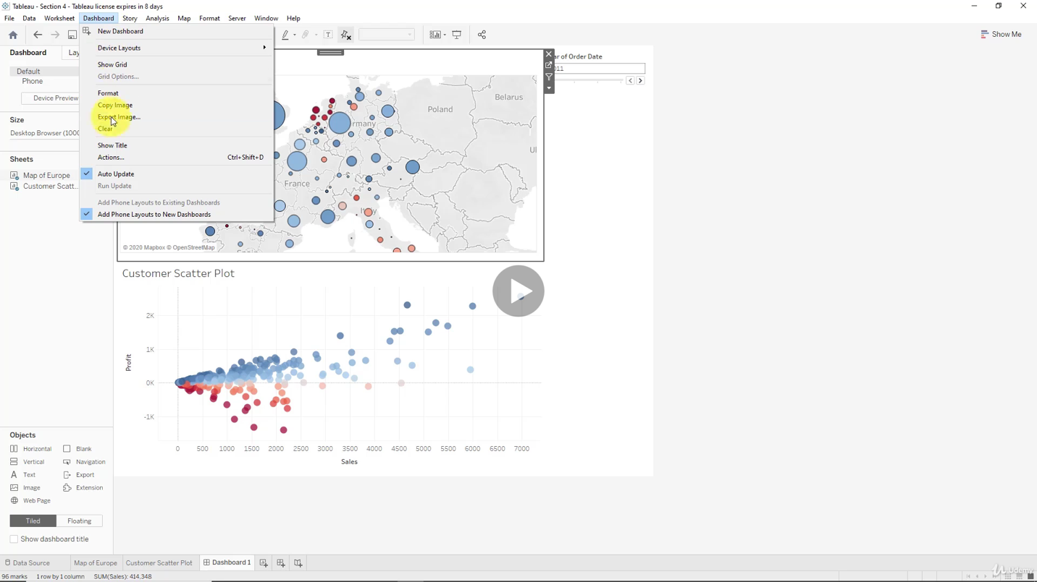

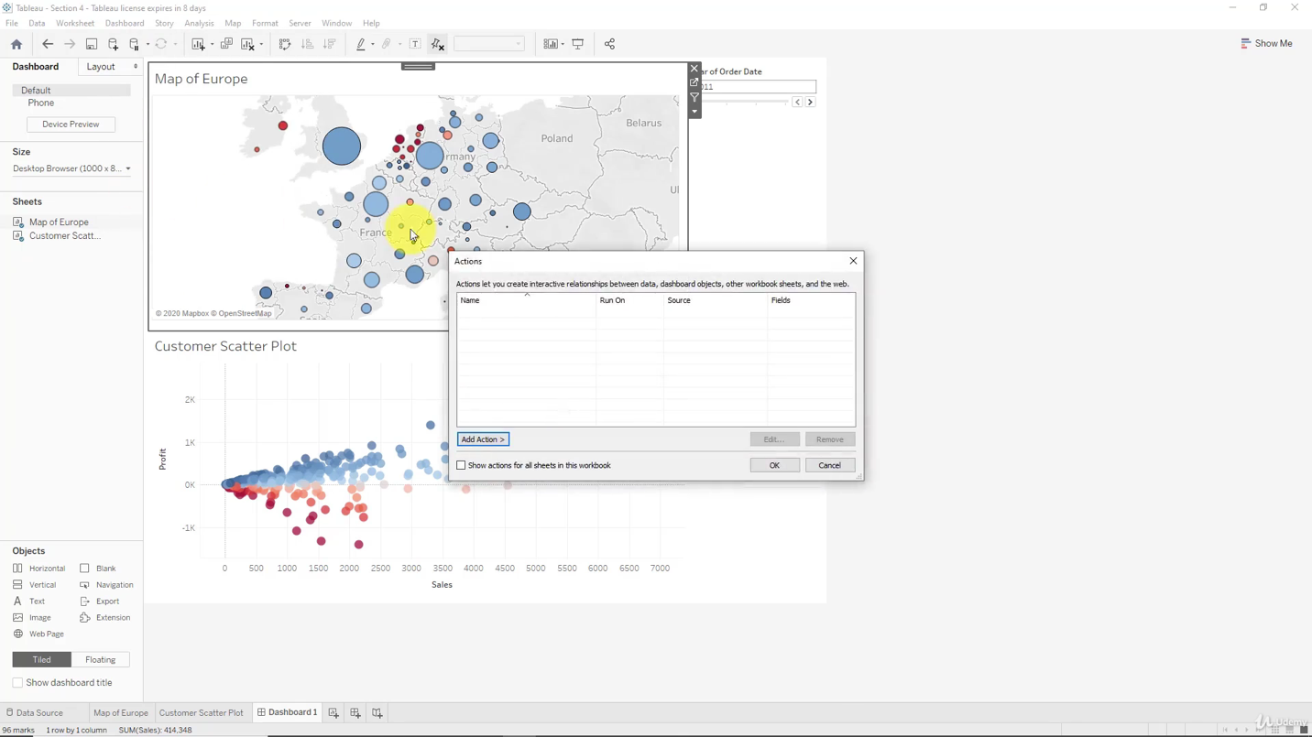

Filter options

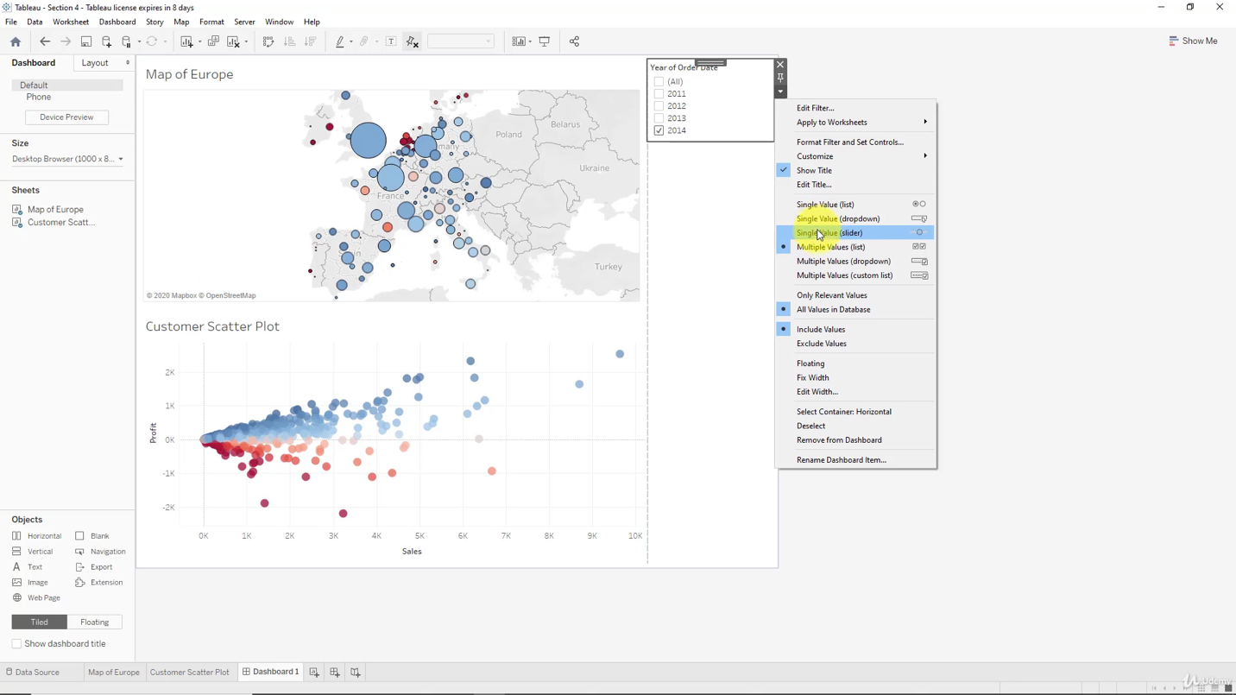

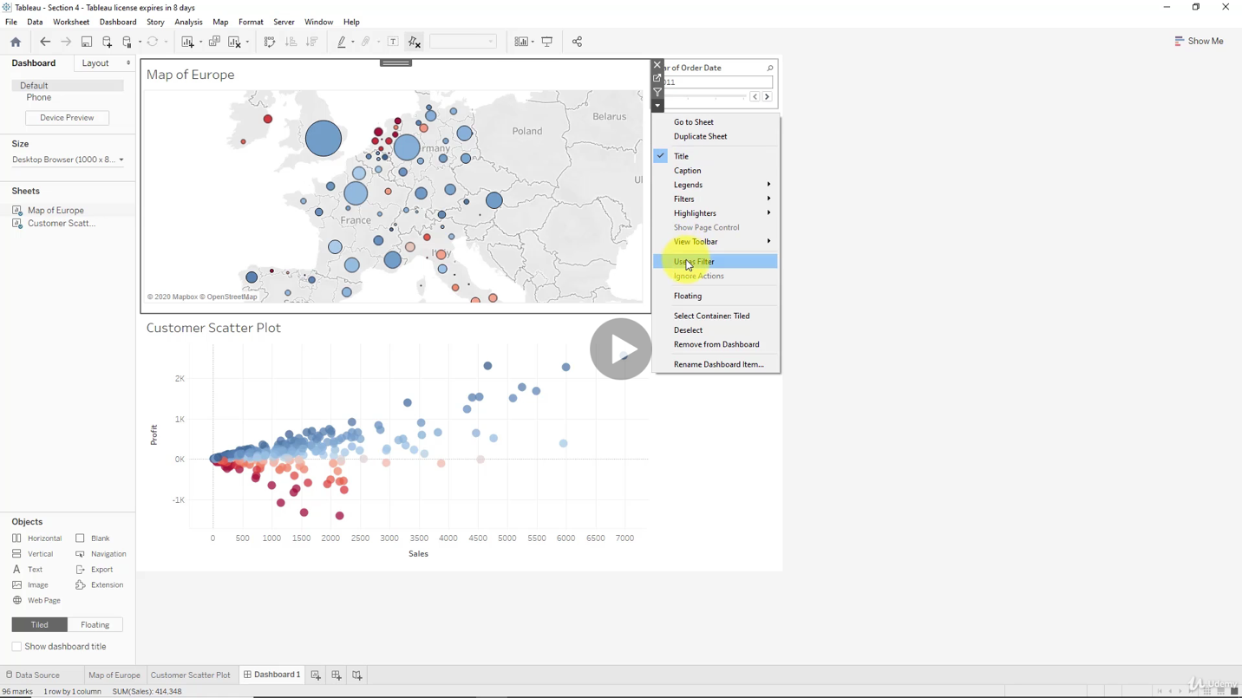

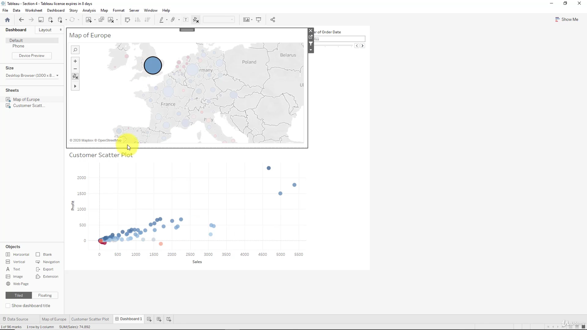

Action details on filter

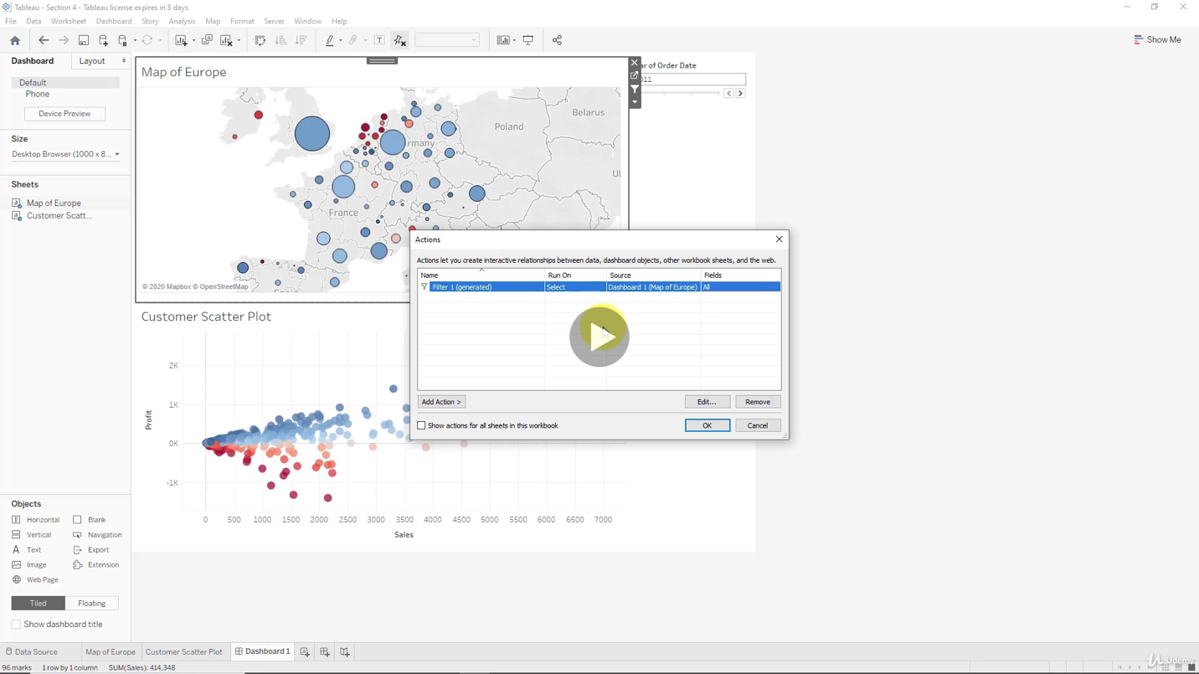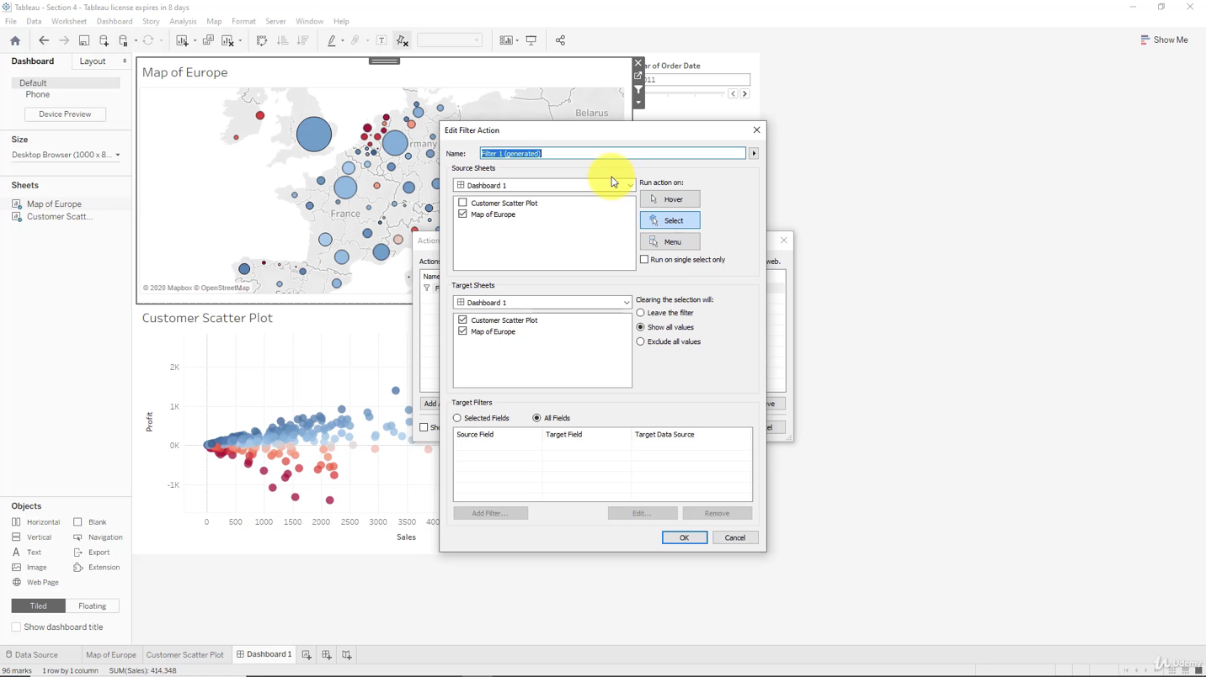

Where to apply the filter

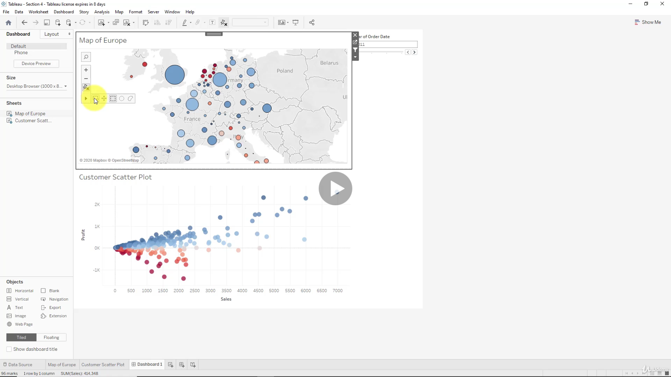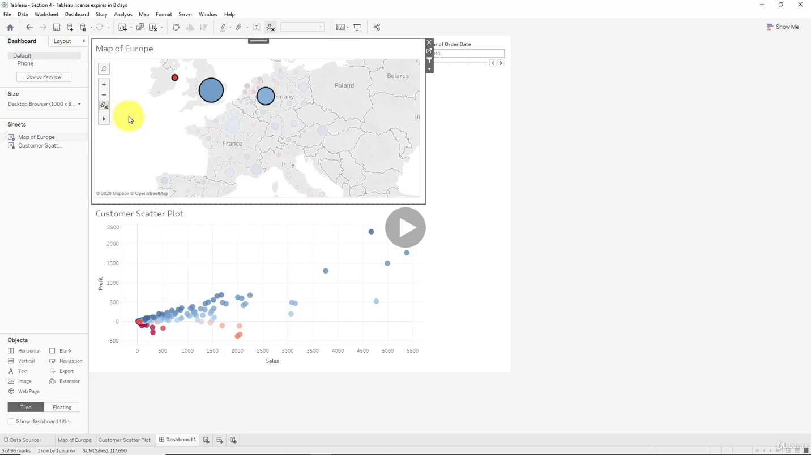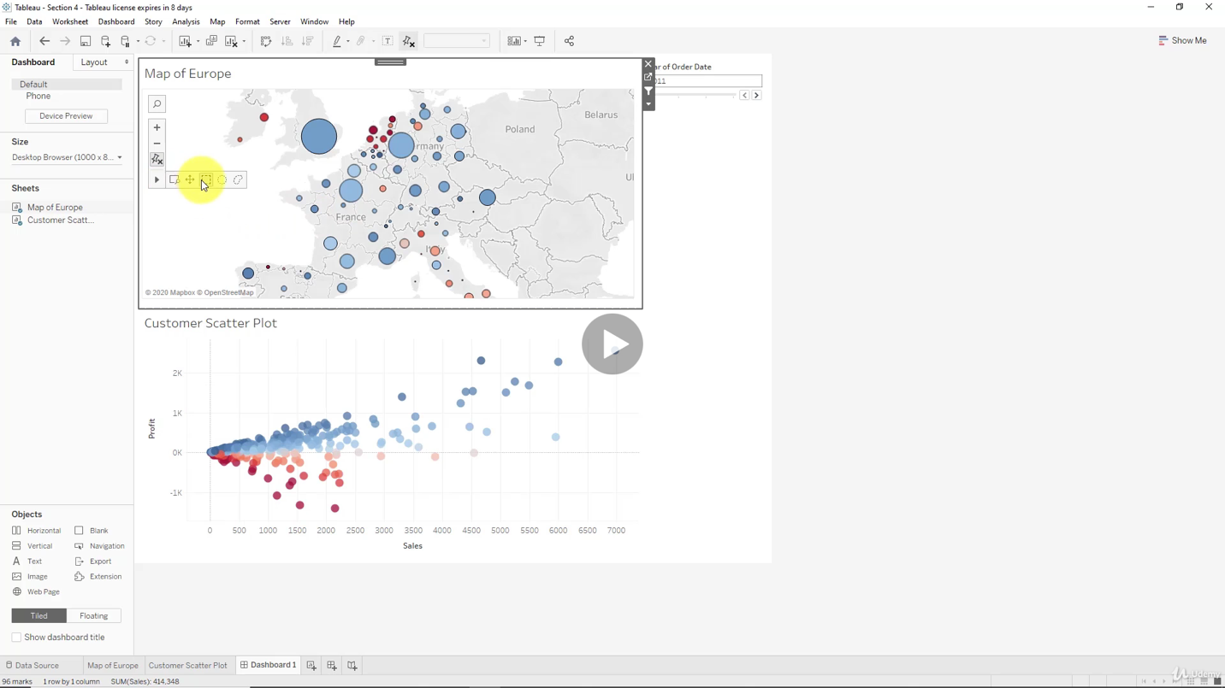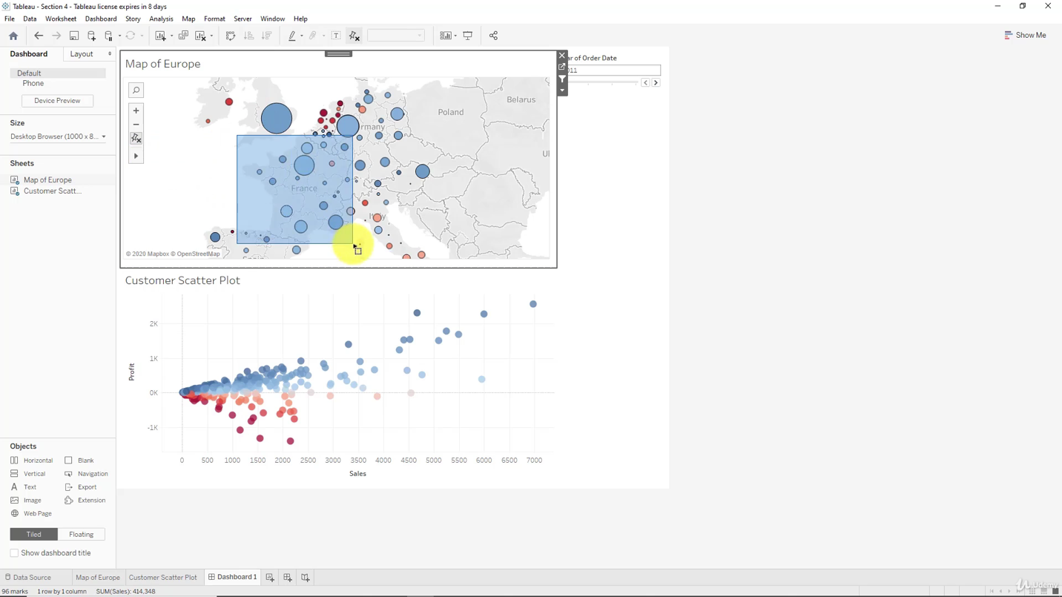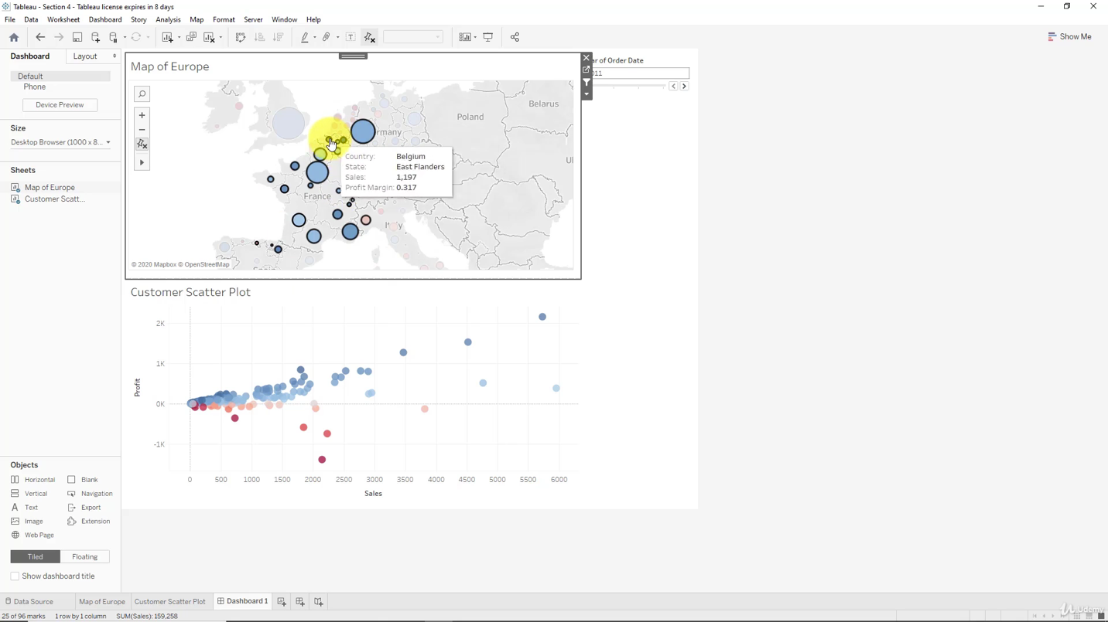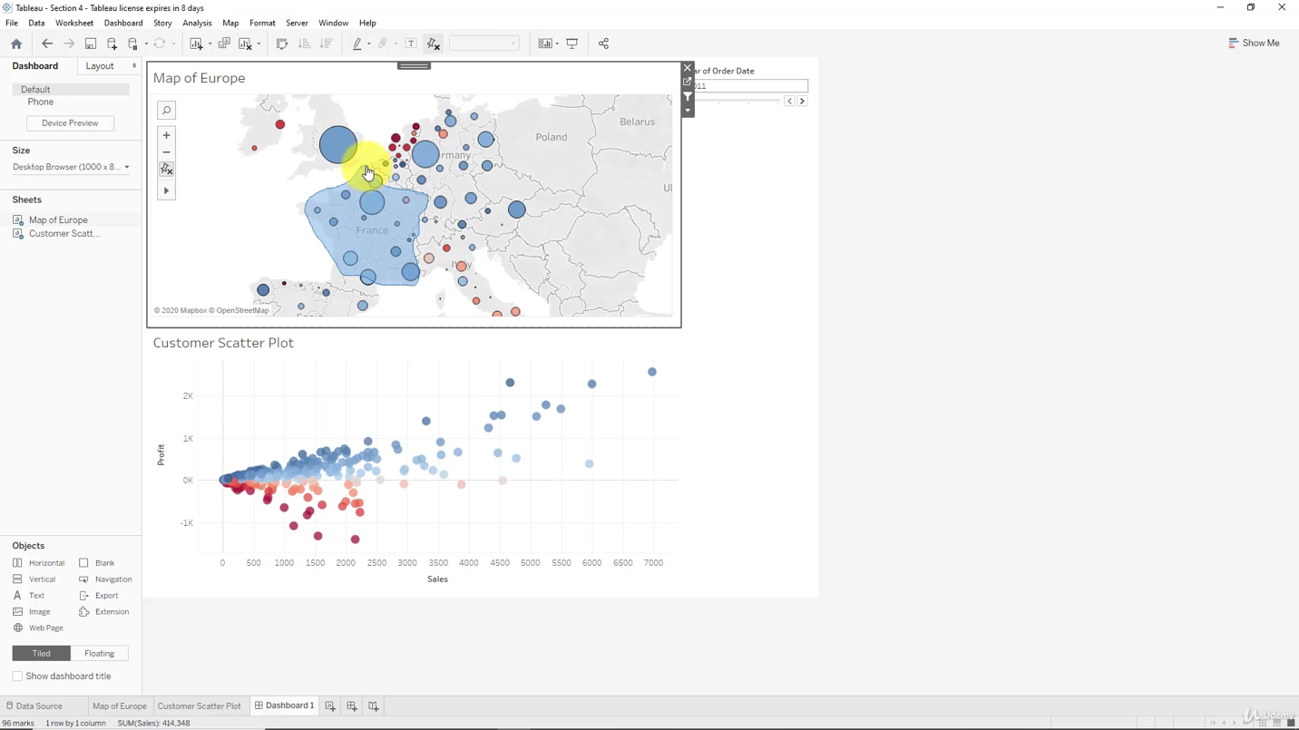

***Adding an Interactive Action - Highlighting***

Adding granularity

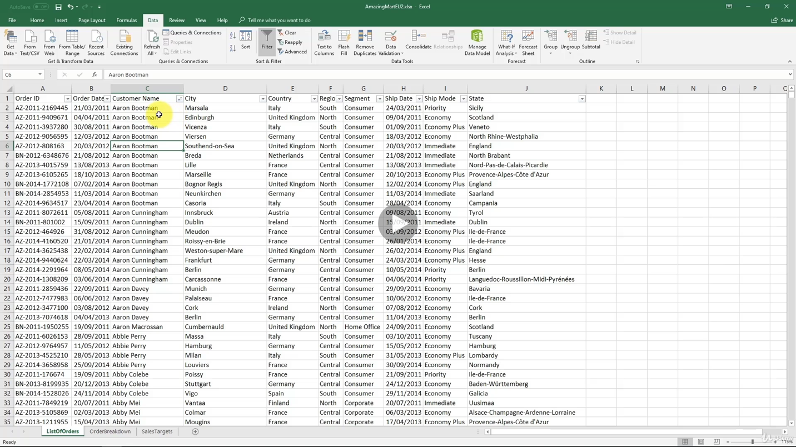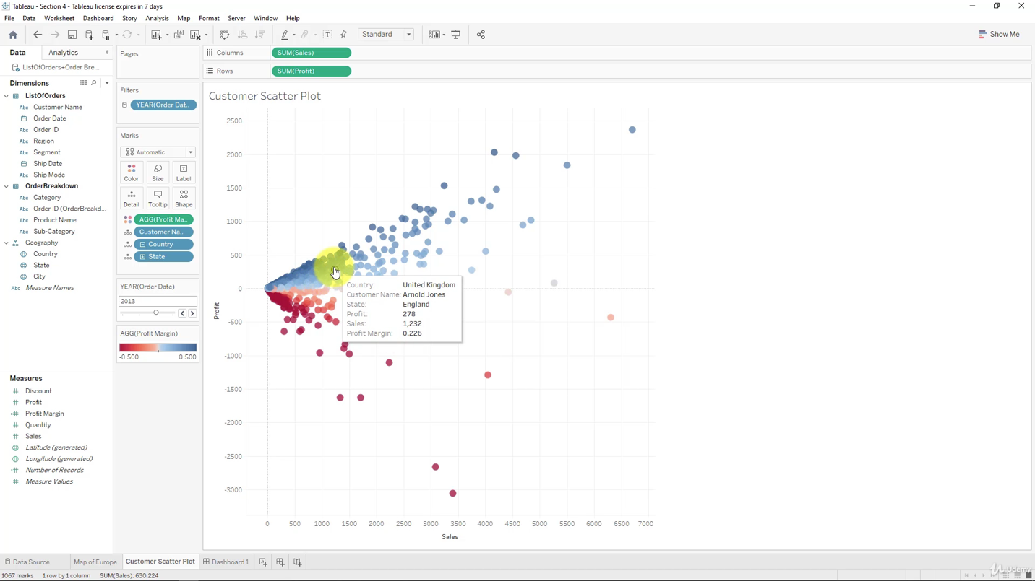

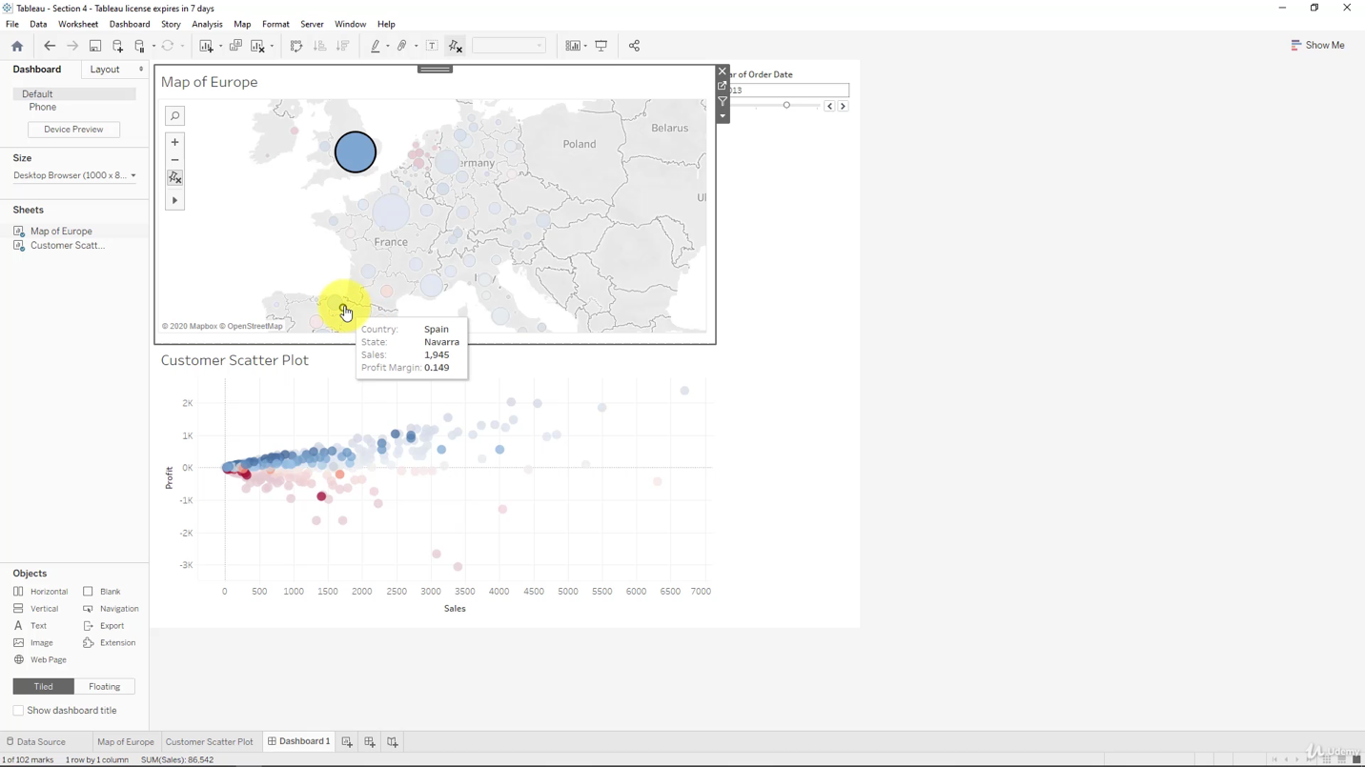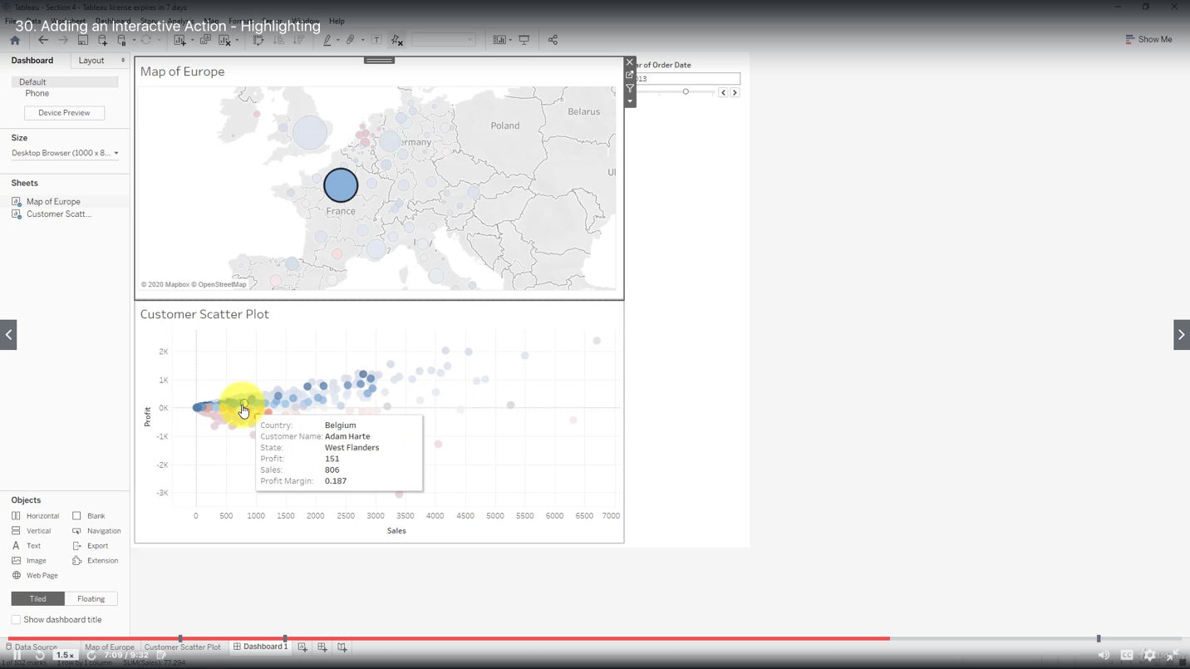

Conceptual difference:

When you use Action: Filter you are removing data from analysis before it is illustrated on the visualization,

when you use Action: Highlight first all of the data us visualized, and only after that the action is applied.

This can lead to discrepancies in results